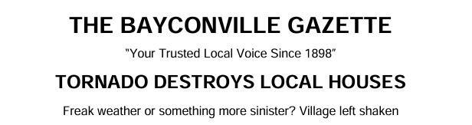
Last week, local residents were left stunned after two homes were mysteriously destroyed by what some are calling freak weather conditions in Bayconville Village.
Master Ham, a well-known resident of Baycon End, described the shocking moment his environmentally friendly cottage was reduced to ruins. Built carefully from straw bales, the home had been a source of pride in the community.
“I had spent hours building the house out of straw bales. I was just having a cup of tea when it blew down.”
Master Ham believes a sudden tornado may have struck the area without warning.
Shortly after, a second property belonging to Master Pork—Master Ham’s older brother—was also destroyed. “I was just listening to my brother’s tale and, blow me down, an almighty gust took my roof off!”

The rapid succession of events has left villagers questioning whether the destruction was purely natural—or something more unusual.
However, not everyone is convinced by the tornado theory. A local woodcutter suggested a more troubling explanation.
“We’ve had problems in the woods—there was a break-in at the Bear’s Cottage, reports of young girls being followed by shady characters, and now this.”
Authorities have acknowledged the concerns. Local police confirmed they are currently investigating the incidents and have not ruled out foul play.



