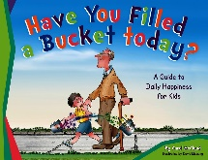

Example
Holly filled her little sister’s bucket today, because she helped her up off the floor and gave her a big hug after she had fallen off her scooter.
Personal, Social & Emotional Development
You can watch this story online. If you spot your child ‘filling someone’s bucket’, please write about it on a bucket outline and we will display these at school.
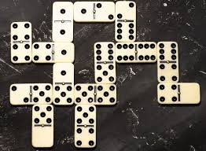



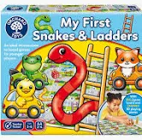
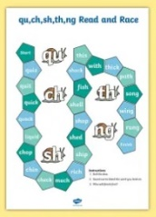
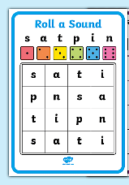
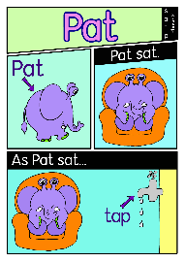
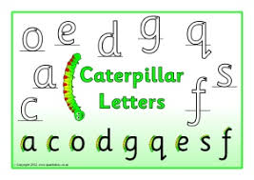
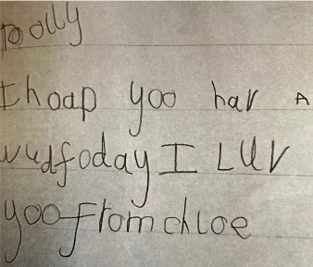

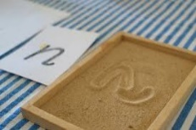
- 1 cup of flour
- ½ cup of salt
- ½ cup of water

Get Creative!
Salt Dough Christmas Decorations
- Follow this cup recipe. This helps children to begin to understand measure.
- Reinforce the language ‘full’, ‘half’ and ‘empty’
Playing games
- Enjoy playing games as a family. Dominos is a great game to support the teaching of number.
- Can your child subitise (instantly seeing how many) the dots on the dice?
- Can your child use their knowledge of ‘more’, ‘fewer’ and ‘1 more’ and ‘1 less’ to compare the dots?
- Who has the most/least number of dominoes/dies?

- Can you see if there is a new board game you could play with your child, to support their turn taking and communication skills.
Reading
There are a range of different online games for children to play, to help them practise their blending skills.
Focus on ‘Phase 2’ sounds, as these are the sounds the children have been taught so far.
In your pack we have also included some practical games you could play with your child too.
PhonicsPlay - Resources  - Buried Treasure  - Picnic on Pluto  - Dragon’s Den  Decodable comics  - Online comics children can read independently | https://www.topmarks.co.uk/phonics/balloon-phonics-cvc-game  - Balloon Phonics | Online Phonics Games (Phase 2) - PhonicsBloom.com  - Flashcards  - Odd Sound Out  - Fishy Phonics  - Match Cards | ictgames || html5 English Games Page  - Phonics Pop (set 1 -7)  - The Dinosaur’s Eggs High Frequency Words (1 & 2)

Writing

- Secure ‘Curly Caterpillar’ letter formation, this can be using chalk, pen, pencil and paint, be creative!
- Thank you cards for presents. Let your child sound out each word and encourage them to write the sounds they can hear, even if there are some missing sounds.
- This example is from a child who has learnt more sounds than the children have at this point in the year, but demonstrates the importance of letting children sound out words themselves, rather than you spelling words for them, because it doesn’t support children to think for themselves.

